**CLIENT SUPPORT / MEMBER SERVICES:**

If a case is received from Care regarding one of these members, and you have confirmed they do not have an account under X3917, please follow the below steps for adding them manually.

*Note: you are only adding the member in question, not everyone on the main plan*

**Step 1**. Open RXCADS and keep the member's profile under X0247 open in AS400 for reference.

**Step 2**. Add member manually under X3917 in RXCADS mirroring the Account and Group number for X0247. The only thing you are changing is the carrier code and the ID/Xwalk.

When entering the ID, you are going to use the exact same ID as the main account, but you will add a 'WPS' at the front. This naming convention can be found in the X3917 CIF under "Eligibility". I have included screenshots below of an example of what the main ID will look like and what the second ID will look like. You MUST add this WPS to move forward with adding them.

X0247 ID/Xwalk:

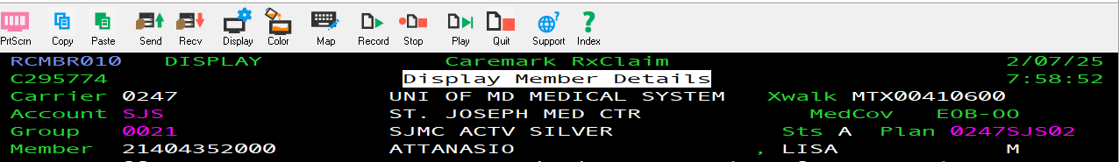

X3917 ID/Xwalk:

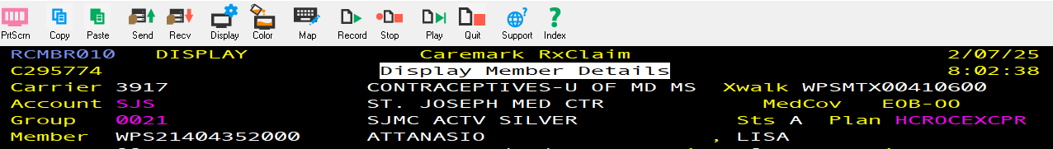

**Step 3**. Once you are on the screen to add the member information, you are going to mirror everything that is on your screen in AS400, including effective dates and family types. The only thing that will need to be changed is the Xwalk, which will not automatically populate. To add, you will do the exact same thing as the ID, just add a 'WPS' at the front of their current Xwalk ID. Please see screenshot above.

**Step 4**. Once member is added, ID cards will automatically order and be sent to member's address in 7-10 days. While ID cards are being processed, you can provide the following processing information to Care.

ID: Xwalk ID for X3917

BIN: 004336

PCN: ADV

GRP: RX3917

Peoplesafe can take up to 24 hours to load, so please check after 24 hours to ensure the profile is loaded correctly.